
Agrupamento de Escolas De Paço de Sousa
Escola Básica de Irivo
Trabalho de Grupo – Estudo do Meio - “Pequenos Astrónomos – As fases da Lua” | 3º Ano
Nome:_____________________________________________ Nº ______  Nome:_____________________________________________ Nº ______  Nome:_____________________________________________ Nº ______  Nome:_____________________________________________ Nº ______ | Data: _____/_______/_____  Avaliação:

- Observa a imagem.

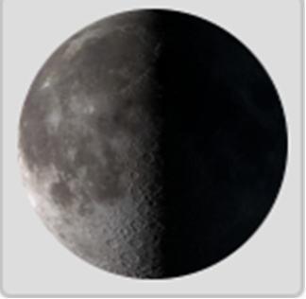

- Pesquisem no Manual, abram os links e investiguem
https://www.youtube.com/watch?v=oRSWOwkyiko

https://youtu.be/OdzJnEmnpNw?list=TLGGfBMxUwyBO9QyNzAyMjAyNg

https://estudoemcasaapoia.dge.mec.pt/recurso/fases-da-lua#h5pbookid=1594&section=top&chapter=h5p-interactive-book-chapter-5de2749a-5810-4cec-a3c8-c0fbcd6d3284

- Devem recolher informação sobre:
- Qual é o nome da fase lunar
- Quando aparece
- Porque acontece
- Uma curiosidade

- Façam o registo do que forem descobrindo sobre a imagem.

_______________________________________________________________________________________________________________________________________________________________________________________________________________________________________________________________________________________________________________________________________________________________________________________________________________________________________________________________________________________________________________________________________________________________________________________________________________________________________________________________________________________________________________________________________________________________________________________________________________________________________________________________________________________________________________________________________________________________________________________________________________________________________________________________________________________________________________________________________________________________________________________________________________________________________________________________________________________________________________________________________________________________________________________________________________________________________________________________________________________________________________________________________________________________________________________________________________________________________________________________________________________________________________________________________________________________________________________________________________________________________________________________________________________________________________________________________

Bom trabalho!!!

